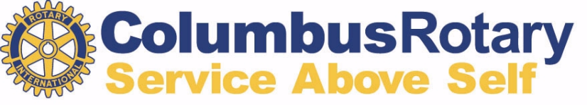

Pivot Point Scholarship
The mission of Columbus Rotary in providing our Pivot Point Scholarship is to support positive and enduring change in the lives of lifelong learners. The Pivot Point Scholarship is intended to support learners who are on a journey to reinvent their lives or make a career change.
Our Pivot Point Scholarships range from $2,500 for full-time students to $1,250 for part- time students, with opportunities to support students seeking other certificate/license programs, as well. Note: Eligible students are those who are NOT graduating before the next academic year that begins in fall, 2025.
Are You a Pivot Point Scholar?
- Are you a Franklin County resident? Do you work in Franklin County?
- Will you graduate after the next academic year begins in the fall?
- Are you a US citizen or do you have documentation of permanent residency?
- Are you a high school graduate who is persevering in spite of life’s challenges that have prevented you from taking a “typical” route to a degree or certification?
- Are you using education to reinvent yourself or make a career change? Are you seeking a bachelor’s or associate degree or other post-high school certificate or license? (We do not fund graduate degree programs).
- Can you demonstrate a commitment to education and the ability to succeed, as shown by your grades, work history, and plans for your future?
Then yes… you’re in Pivot Point mode, and we’re happy you found Columbus Rotary!
APPLICATION INSTRUCTIONS
The following information will be needed to complete the online application.
- Schools (and dates) of coursework you have completed since high school.
- Recent employment history
- A 300 – 500 word essay of what makes you in Pivot Point mode – someone who is rising above life’s challenges and working to achieve success. You may also include
comments on your personal and family background, education achievement and goals, any experience as a community volunteer, and your desired future direction.
Submission Deadline: midnight on April 1, 2025
You can apply online at columbusrotary.org – under the “Initiatives” tab.

